RDBMS and SQL
ASSIGNMENT DONE BY NISHANT KAUSHIK

- Create Entity - Relation Diagram for the restaurants management system. (20 marks)
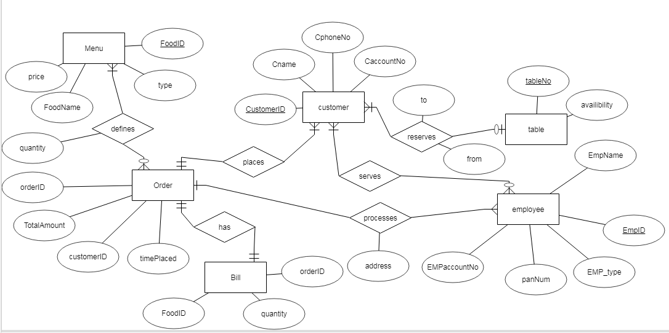

2. Pick Customers module of the ER Diagram and created the Tables with Proper relationships. (30 marks)
Module details: Restaurant's Customers including order, menu(including price). Billing.

CREATE TABLE `order1` (
`oid` varchar(10) NOT NULL,
`customerid` varchar(10) NOT NULL,
`timep` datetime NOT NULL,
PRIMARY KEY (`oid`) );

employee | CREATE TABLE `employee` (
`EmpID` varchar(10) DEFAULT NULL,
`EmpType` varchar(10) DEFAULT NULL,
`panNum` varchar(10) DEFAULT NULL,
`EmpaccNo` varchar(10) DEFAULT NULL );

CREATE TABLE `rtable` (
`tableNo` int(3) DEFAULT NULL,
`avail` int(1) DEFAULT NULL );

CREATE TABLE `customer` (
`cid` varchar(10) NOT NULL,
`cname` varchar(10) DEFAULT NULL,
`cno` varchar(10) DEFAULT NULL,
PRIMARY KEY (`cid`) );

CREATE TABLE `menu` (
`foodid` varchar(10) DEFAULT NULL,
`foodtype` varchar(3) DEFAULT NULL,
`foorname` varchar(10) DEFAULT NULL,
`price` int(4) DEFAULT NULL );

CREATE TABLE `bill` (
`foodid` varchar(10) NOT NULL,
`qty` int(3) DEFAULT NULL,
`orderID` varchar(10) NOT NULL);

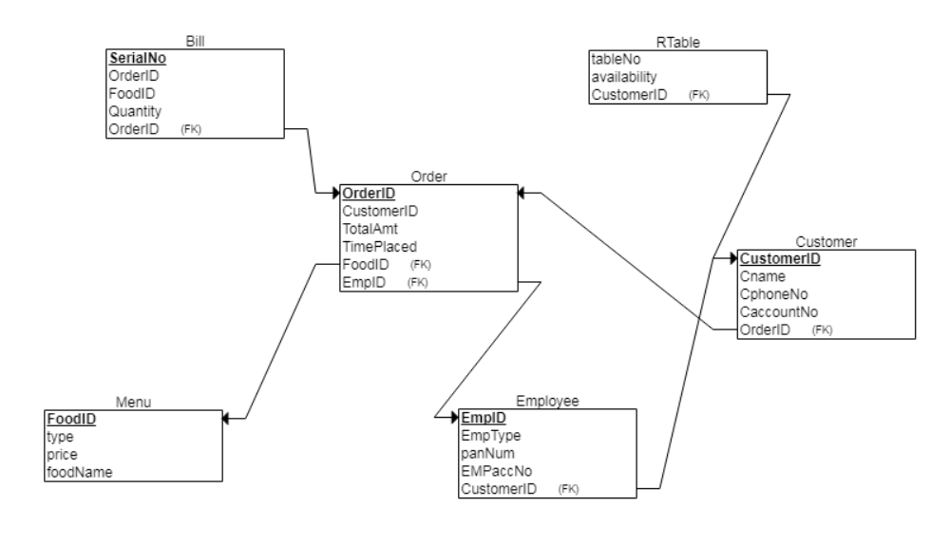
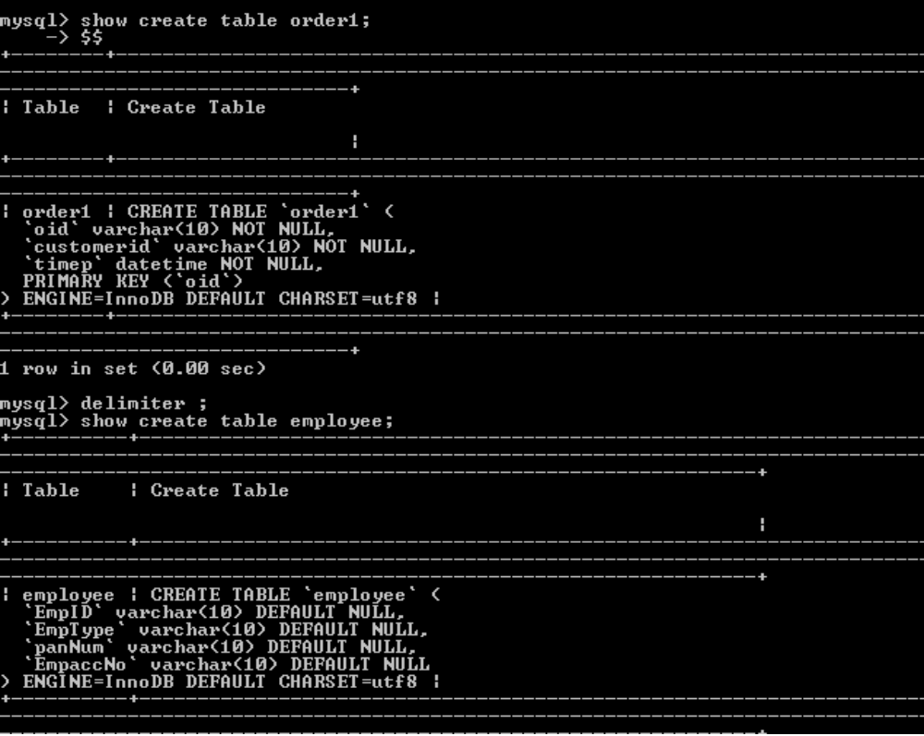

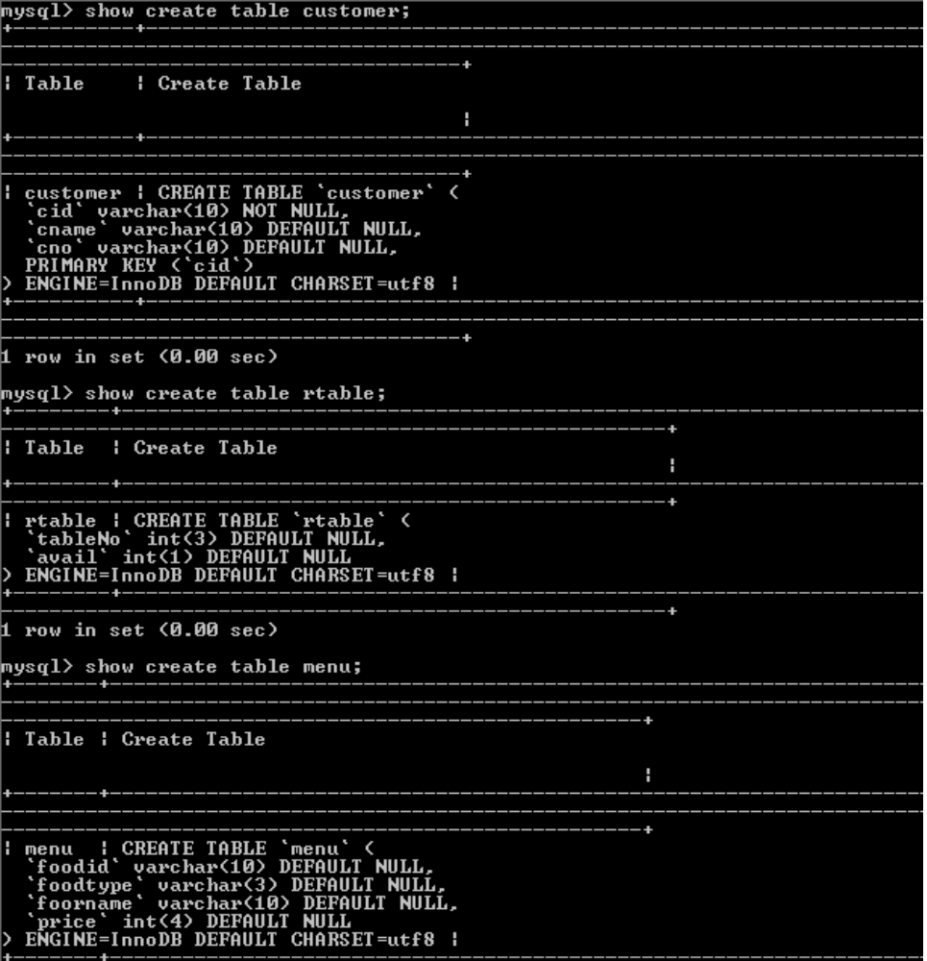

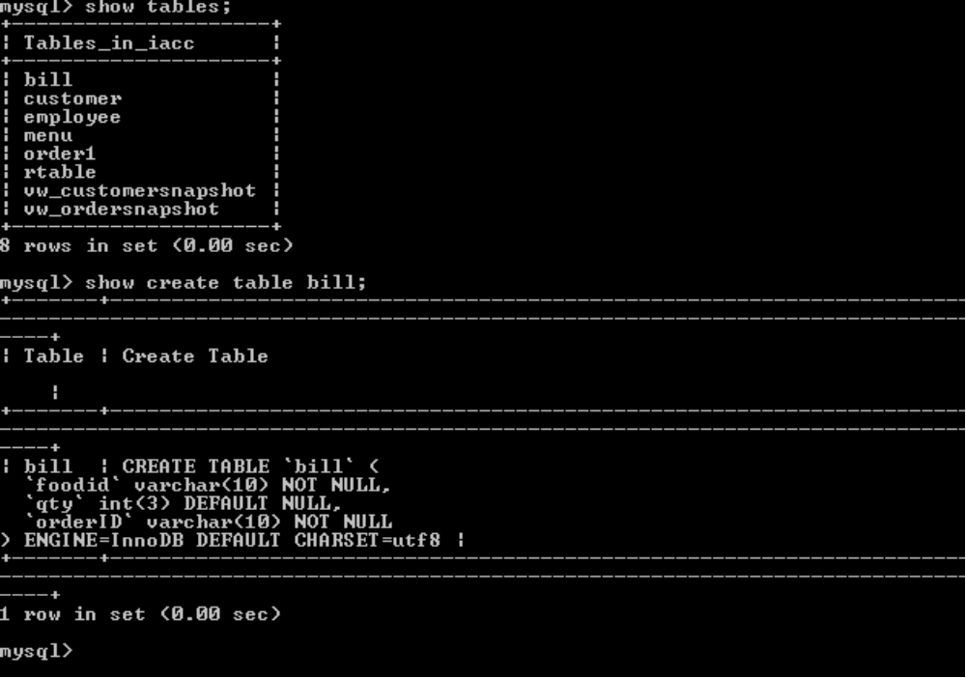

- Insert some data.
Insert into rtable values (1,1);
Insert into rtable values (2,1);
Insert into rtable values (3,0);

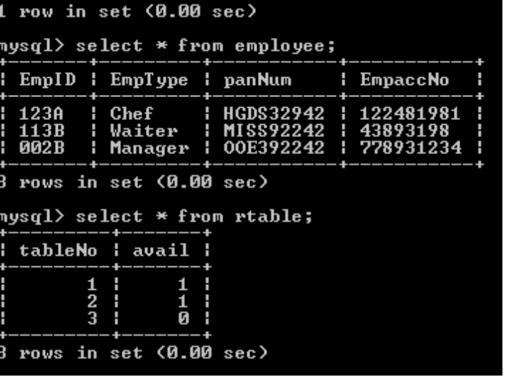

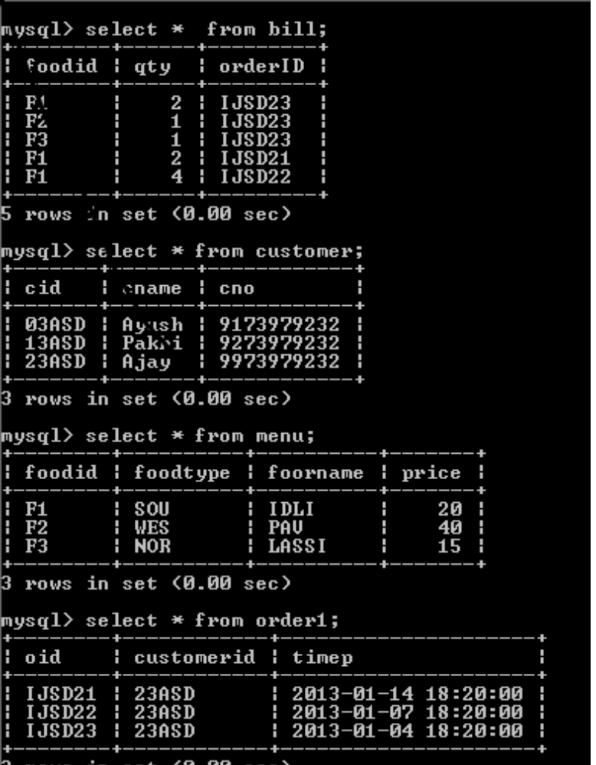

For the below things you can assume your own business requirement and do the followings things.

5. Create following Views: (10 marks)
vw_customerSnapshot : To show customer with most visits, and customer Details.

create vw_customerSnapshot as select * from customer where cid in ( select customerID from order1 group by customerID order by count(customerID) desc);
select * from vw_customerSnapshot;

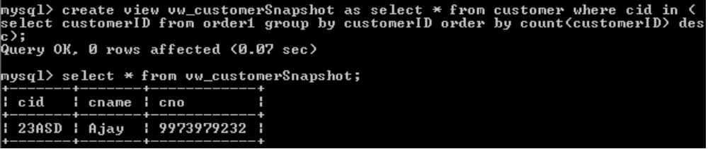

vw_OrderSnapshot: To show Most Ordered Item, and item details.

create view vw_OrderSnapshot as select * from menu where foodid in ( select foodid from bill group by foodid order by count(foodid) desc) LIMIT 1;
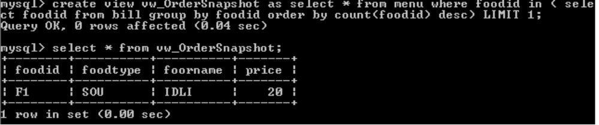
select * from vw_OrderSnapshots;

6. Create a function to fetch the time since order was placed by a customer. (10 marks)
fn_GetOrderTimeElapsed(CustomerID)
drop function if exists fn_GetOrderTimeElapsed;
delimiter $$
create function fn_GetOrderTimeElapsed (id varchar(10) ) returns int(4) begin declare timestm datetime; select timep into timestn from order1 where oid=id; return(timestampdiff(hour, timestm, NOW() ) ); END $$
delimiter ;
select oid,fn_GetOrderTimeElapsed(oid) from order1 order by oid;

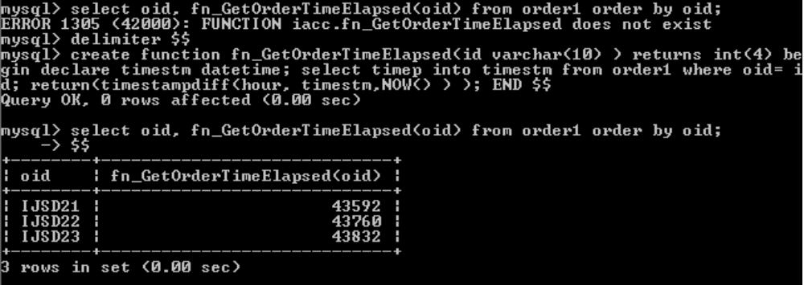

7. Create a Procedure to get Order for a customer (15 marks)
sp_GetOrder(IN CustomerID) (Returns Order Details as a Table)
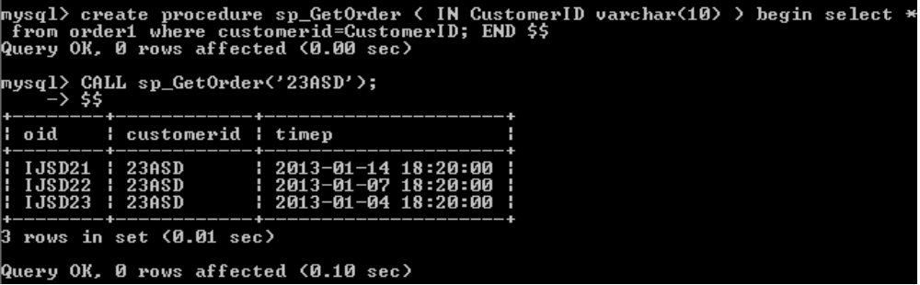

drop procedure if exists sp_GetOrder;
delimiter $$
create procedure sp_GetOrder ( IN CustomerID varchar(10) ) begin select * from order where customerid=CustomerID; END $$
delimiter ;
CALL sp_GetOrder('23ASD');

8. Create a Procedure to Generate bill for an order. (15 marks)
sp_GenerateBill(IN OrderID, OUT BillAMT)

drop procedure if exists sp_GenerateBill;
delimiter $$
create procedure sp_GenerateBill(IN ordid varchar(10), OUT bamt decimal(8
,2)) begin select sum(m.price*b.qty) into bamt from menu as m RIGHT JOIN bill as
b on m.foodid = b.foodid where orderID=ordid; END $$
delimiter ;
call sp_GenerateBill('IJSD23',@amt);
select @amt;

